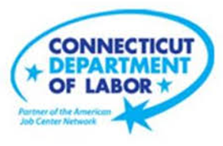

**NEW WEEKLY JOB POSTINGS FROM   
HELP WANTED ONLINE  
Office of Research**

**Week Ending April 15th, 2023: New Ads Drop 21% Continuing Recent Week-to-Week Volatility.**WETHERSFIELD, April 21st, 2023 – During the week ending April 15th, 2023, there were 7,591 new postings, down 2,071 new ads or -21% over the week. This over-the-week drop follows a new ad jump of 2,395 new ads during the prior week. The table below illustrates the volatile top-line shifts over the past few months at both the state and national levels. All but three industries had over the week decreases. Health Care & Social Assistance had the largest decrease, down 605 new ads which account for 29% of the total ad drop over the week. Other industries with large shifts include Retail Trade, down 343 new ads, and Manufacturing, down 189 new ads. These industry shifts correspond with occupational new ad shifts, the three occupations with the most ads, Registered Nurses, Retail Salespersons, and Supervisors of Retail Sales Workers were down 31%, 18%, and 16% respectively. Despite the recent increased volatility, the past two weeks have seen four-week moving averages above 8,000 ads per week for the first time since early October 2022.  
  
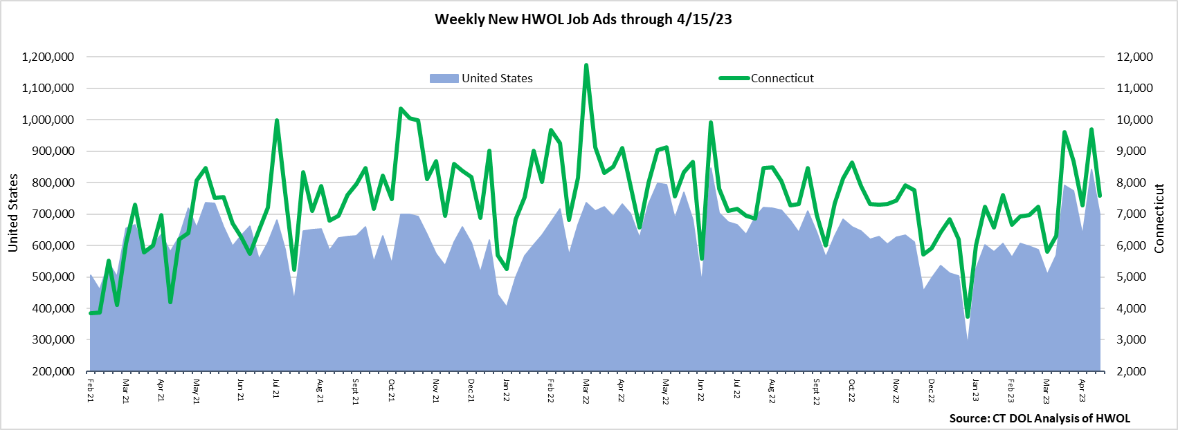 **Industries** with the most new postings include Health Care & Social Assistance, Retail Trade, and Finance & Insurance.

**Occupations** with the most new postings include Registered Nurses, Retail Salespersons, and First-Line Supervisors of Retail Sales Workers.

**Employers** with the most new postings include Cigna Corporation, Hartford Healthcare, and Dunkin’.

**The three industries with the most new job postings were:**

* **Health Care & Social Assistance** (1,644 new postings, -27% over the week)
* **Retail Trade** (868 new postings, -28% over the week)
* **Finance & Insurance** (719 new postings, -20% over the week)

   
 During the week ending April 15th, 18 of 21 industries had over-the-week declines. Among those decreasing industries, three were down by over 50%, three were down between 30%-49%, and nine were down between 20%-29%. A combined 55% of the 2,071 new ad decline occurred in Health Care & Social Assistance (-605 new ads), Retail Trade (-343 new ads), and Finance & Insurance (-181 new ads). Employers with the largest over-the-week declines in these three respective industries were Yale-New Haven Health System (-295 new ads), UnitedHealth Group (-125 new ads), and The Home Depot (-113 new ads). Among the three increasing industries, the largest was Educational Services, up 129 new ads or +32%. Educational Service employers with the largest over-the-week increases include Stratford Public Schools (+43 new ads), Bridgeport Public Schools (+37 new ads), and New Haven Public Schools (+16 new ads).  
  
 For more information on total job ads by industry for Connecticut and its labor market areas, see the monthly report available here: <https://www1.ctdol.state.ct.us/lmi/hwol.asp>

**New Job Postings by Occupation** 

**The occupations with the most new postings were:**

* Registered Nurses (389 new postings, -31% over the week)
* Retail Salespersons (289 new postings, -18% over the week)
* Supervisors of Retail Sales Workers (233 new postings, -16% over the week)

**Employers with the Most New Job Postings** Employers with the most new job postings during the week ending April 15th, were mostly within Health Care & Social Assistance, Retail Trade, and Educational Services. The employers with the most new ads in these three respective industries were Hartford Healthcare (147 new ads), CVS Health (46 new ads), and Stratford Public Schools (45 new ads). Overall, the 25 employers with the most ads account for a combined 18 percent of total new ads. Among the 25 employers shown above, 12 decreased over the week, one was unchanged, and 12 increased. Among decreasing employers, the largest drops occurred at Yale-New Haven Health System (-295 new ads), UnitedHealth Group (-125 new ads), and The Home Depot (-113 new ads). The 9 other decreasing employers had new ad declines of 58 ads or less. The largest employer increases occurred at Cigna Corporation (+66 new ads) and KPMG (+66 new ads).  
  
**What is HWOL?**The **Conference Board Help Wanted Online**® Data Series (HWOL) measures the number of new, first-time Online job postings and jobs reposted from the previous month for over 16,000 Internet job boards, corporate boards, and smaller job sites that serve niche markets and smaller geographic areas. To view more HWOL data, go to: <https://www1.ctdol.state.ct.us/lmi/hwol.asp>